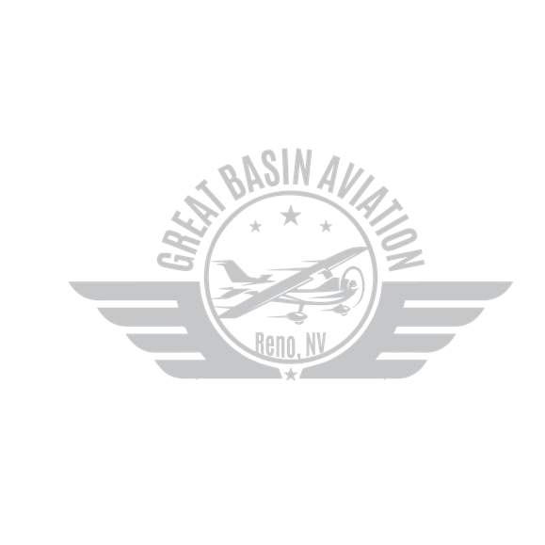

Private Pilot Certificate – Airplane, Single Engine, Land

- What is a private pilot?
  - A private pilot license allows you to fly almost anywhere in the United States and even outside the United States when you comply with regulations of the foreign country where the aircraft is operated.
  - You can carry any number of passengers, and you can share certain operating expenses with your passengers.
  - A private pilot has fewer limitations than a recreational or sport pilot. Although there are currency and medical requirements to make sure you stay proficient and healthy, only a few other factors affect when and where you can fly.
  - Once you earn your license, you are free to wander around in the skies below 18,000 feet to your heart's content.
  - You can fly in some weather conditions but not others, at least without additional training.
  - You can fly at night as long as you have received the required night training.
- To be eligible for a private pilot certificate, a person must:
  - Be at least 17 years of age
  - Be able to read, speak, write, and understand the English language.

- FAA Minimum Flight Time:
  - 40 hours total Flight Time
  - 20 hours Flight Instruction
  - 10 hours Solo including:
    - 5 hours solo Cross-Country
    - 150 nautical mile Cross-Country with 3 full stop landings
    - 3 Takeoffs and Landings at an airport with a Control Tower
  - 3 hours Cross-Country dual
  - 3 hours Night Flight including:
    - 100 nautical mile Cross-Country
    - 10 Takeoffs and Landings to a full stop
  - 3 hours Instrument Training
  - 3 hours Test Prep Flight Training within 60 days of practical test.
Cost: Based on using a Cessna 172, 65 hours of flight time, 45 hours instruction*

Private Pilot training:
- 10 hours ground instruction
  - 10 hours x $45/hr ground instructor = $450
- 45 hours of flight instruction
  - 45 hours x $80/hr flight instructor = $3,600
- 65 hours aircraft time
  - 65 hours x $165/hr = $10,745
  - 5% (as of June 2021) Fuel Surcharge = $516.75
    - Fluctuates based on market

Additional costs for required items:
- Ground School (average) = $250
- FAA Medical Exam (3rd Class) = $120
- FAA Written Exam = $165
- FAA Practical Test = $650
- Miscellaneous Books and Supplies = $100
- Renter’s Insurance = $350 (yearly cost)

Total Cost: $16,946.75

*FAA minimum flight time is 40 hours. 20 hours instruction. Numbers based on national averages.

Flight School Payment Options:

- Cash (10% cash discount on aircraft rental)
- Check
- Credit Card
- Finance (Pilot Finance or AOPA Finance)

